o-



AHOY from Mrs.

Rumore

’s



Class

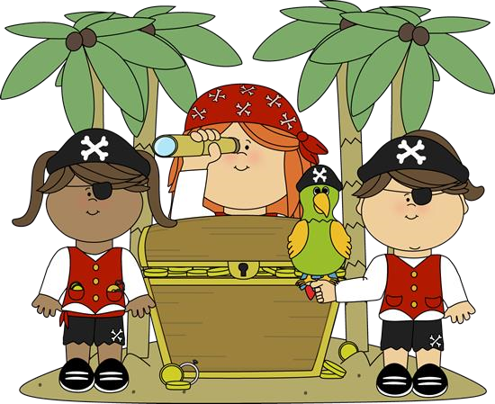

Captai

ns

Corner

Hello

!!!

1

st

grade students are looking

forward

to our

upcoming field trip to the fisheries!

We had so

much fun celebrating the 100

th

Day of School

and building a robot during our stem activity!

We have also learned cool facts about the

Chinese New

Year! This is the year of the snake!

Hope you all have a wonderful long weekend!



Important Dates

**2**

**/**

**5**

**/25**

-

Field Trip UF Fisheries K,1,2

**2**

**/7/**

**25**

-

Field Trip UF

Fisheries 3,4,5

**10**

**/**

**2**

**-**

**2**

**/**

**14**

-

Kindness Week

**2**

**/17/**

**25**

-

No School-President’s Day

**1**

**2**

**/**

**25**

**9**

**/**

-

Early Release WW Wednesday

Wednesday

Yoga Pose:

**Seated Fo**

**rward Bend**

WOW

word:

**Encourage**

Skills of the Week

Week 23

Feb.

3

rd

-

Feb. 7th

**ELA**

:

Long I

; Expository Writing

**Reading**

:

Interjections;

Proper Nouns

**Math**

:

Adding

addends

in

any order

**Social Studies**

:

None this week

**Science**

:

Unit 3

:

Obje

cts

in the Sky

**S**

**p**

**elling Words**

:

race; lace; brace; wage;

cage; age; far

Reminders:

•

Fie

ld Trip Wednesday

•

Bring in Safety Patr

ol Change

•

Volunteer opportunities

posted on signup Genius

