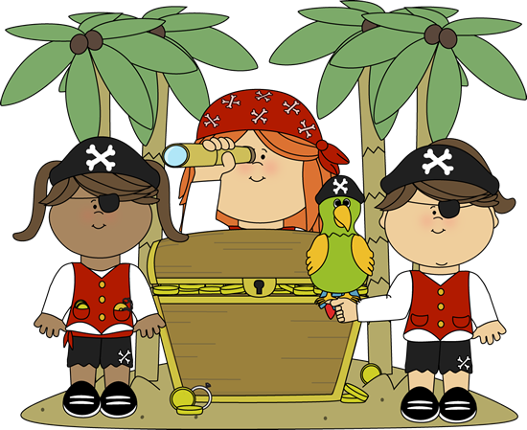

Captains Corner

Merry Christmas!!!!!

This was a wonderful week at HLA! Thank you all for supporting our Holiday Program. I was SO proud of each student!

We are busy making lots of Christmas crafts and learning in fun ways until the break! There is no spelling list this last week of school. Most families are incredibly busy this time of year. I will not be here Thursday or Friday. But I wish you all a beautiful holiday season!!!

Important Dates

**12/16-**Alachua Fire & Rescue is coming to HLA

**12/17 & 12/18-**Cooking Club Days

**12/18-NO SCHOOL-**Early ReleaseWednesday

**12/20-**PJ & movie day!Last day ofschool! Santa is coming to HLA!

**12/23/24-1/3/2025-**Winter Break

**1/6/2025-**School resumes

WOW word: **Trust**

Skills of the Week

Week 18

ELA: Plural Nouns

Reading: Narrative writing  
Math: Addition Strategies  
Social Studies: None this week  
Science: None this week  
Spelling Words: No words this week

Reminders:

*Check SignUpGenius for volunteer opportunities

*No spelling test this week!

**Word of the week**: Believe

**Yoga Pose**: Plank



AHOY from Mrs. Rumore’s Class