**Thank you!**

**Dear Parents and Guardians,**

**I just wanted to take a moment to thank you all. Teaching is a very tough and often frustrating profession. Very rarely does my day end at 2:45. Often, I’m home grading papers, designing plans, or responding to emails, sometimes until 9-10:00 at night. What makes it all bearable is you.**

**The support that you have shown me this year has been tremendous. In year’s past, I never paid attention to the end of the year TIPS assignment or survey. Coming from Alachua Elementary, it was just a way for parents to anonymously write mean things about you and the school. For whatever reason, I read your responses this year, and was absolutely blown away by the thoughtful and complimentary remarks that you took the time to address. This is a tough job. However, when you’re blessed with supportive parents like you all, you remember why you became a teacher. Thank you all for trusting me with your children this year. I hope they have matured and grown intellectually over the past 36 weeks.**

**Don’t forget to join us on Wednesday, May 29th from 11-12 for graduation. Feel free to stay afterwards for a light lunch planned by Anisah Mahmood.**

**Sincerely,**

**John M. Becker**

May 24, 2019

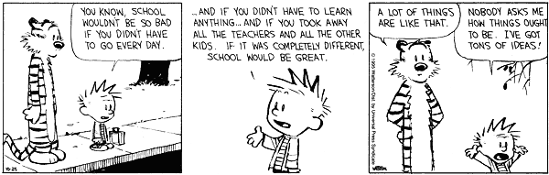

THE

BECKER BULLETIN