**Happy Holidays!**

**This will be the last newsletter that you will receive in 2018. The next Becker Bulletin will go home when we return from the Winter Holiday on Monday, January 7, 2019. We will only have four spelling assignments that week since students won’t receive their words until that Monday.**

**I hope that each and every one of you has a wonderful vacation, surrounded by friends and family. Have fun, make some memories, and be sure to talk about the true meaning of the holidays with your loved ones. And, whenever possible, practice those math facts with your children! We don’t want them forgetting everything they’ve learned during their time off!**

**December 14, 2018**

|  |
| --- |
| **SS: Students just tested on the Age of Exploration. Don’t forget that Explorer mini-book projects are due this Wednesday, December 19th.**  **ELA: This week, we covered understanding characters, contractions, and the prefix, “inter-.”**  **Math: We just started on Ch. 6, which will focus on multiplying and dividing decimals. We’ll have to continue this after the holidays.**  **Science: We will be studying Earth and Space when we return from vacation. We’ve been using our science block to catch up on work and to do our Mid-Year exams.** |
| **Word of the Week:**  **We did not have a “Word of the Week” this week, due to our preparation for the holiday concert.** |
|  |

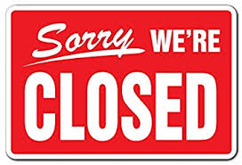

---------------------------------------------------------------------------------------------------------------------------------------------

I have read the December 14 edition of *The Becker Bulletin*

Student Signature ______________________________ Parent Signature ________________________________

Questions/Comments ____________________________________________________________________________________________________________________________________________________________________________________________________________________________________________________________

#### Spelling

**Reminders**

**Holiday Concert:**

**Our yearly holiday concert will be held at the Town of Tioga center stage on Thursday, December 13th from 6:00-7:00 p.m. Students need to be there by 5:45, and should be neatly dressed.**

**Pajama Day:**

**We will have our annual “Pajama Day” on Thursday, January 20th. Students need to dress appropriately and wear sneakers for P.E. If parents would like to contribute snacks, we’ll have a party after lunch.**

#### Miscellaneous

#### The Week In Review

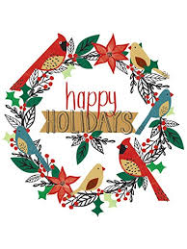

THE

BECKER BULLETIN